**Tool for Continuous Integration:**

**Gitlab CI**

[GitLab CI](https://about.gitlab.com/product/continuous-integration/) is a free continuous integration tool with an open-source code. This highly scalable tool is easy to install and set up for projects hosted on GitLab thanks to GitLab API. Apart from testing projects and building them, GitLab CI can deploy builds. This tool points out the areas that need improvement in the development process. Developers working with GitLab usually choose GitLab CI without thinking twice as they automatically get seamless project integration.

Highlights:

* Docker support
* Easy configuration of the build server
* Runs parallel builds across multiple machines
* Available APIs for numerous features allow deep product integration
* An option to secure project data with Confidential Issues
* Better Docker integration
* Scaling runners is simple
* Parallel job execution within phases
* Chance of directed acyclic graph pipeline
* Very scalable as a result of concurrent runners
* Merge request integration
* Easy to add jobs
* Easy to handle conflict issues
* Good security and privacy policies

With the aid of GitLab CI/CD, you can control Git repositories with total control over branches and several other facets to keep your code safe from sudden threats.

GitLab CI/CD is “Self-Hosted“ and “FREE” that is why developers prefer it more

In GitLab CI/CD, every single project has a tracker that will track the problem and carry out code reviews to improve efficiency.

**GITLAB DOCUMENTATION LINK:**

https://docs.gitlab.com/ee/ci/quick_start/ - this is how to get started on gitlab ci. It is pretty straightforward and simple.

<https://docs.gitlab.com/ee/ci/> - Gitlab ci documentation. Super useful because it contains concepts. Configuration, features set, examples, administration, among others.

<https://about.gitlab.com/resources/> - additional resources

<https://docs.gitlab.com/ee/ci/examples/index.html> - more examples on how to use gitlab ci

Gitlab Maturity

<https://about.gitlab.com/company/history/>

https://about.gitlab.com/is-it-any-good/

Gitlab’s first ever commit was in 2011, and they have grown their company from 2011 to 2021 to 1200 worldwide all remote employees. They own 2/3 of the market share in the self managed Git market. It is currently second in the CI/CD solution market and the fastest growing.

**TOOL FOR REAL TIME ERROR MONITORING**

### [Sentry](https://sentry.io/welcome/)

#### ****Overview****

Sentry is one of the first and the most popular error monitoring tools that is now becoming a platform, preferring to call themselves an “application monitoring platform”. It has a big variety of features that help solve application issues.

#### ****Main features/killer features****

The main three features of Sentry are:

* Breadcrumbs;
* Context;
* Releases.

**Breadcrumbs** show the events that lead to the error.

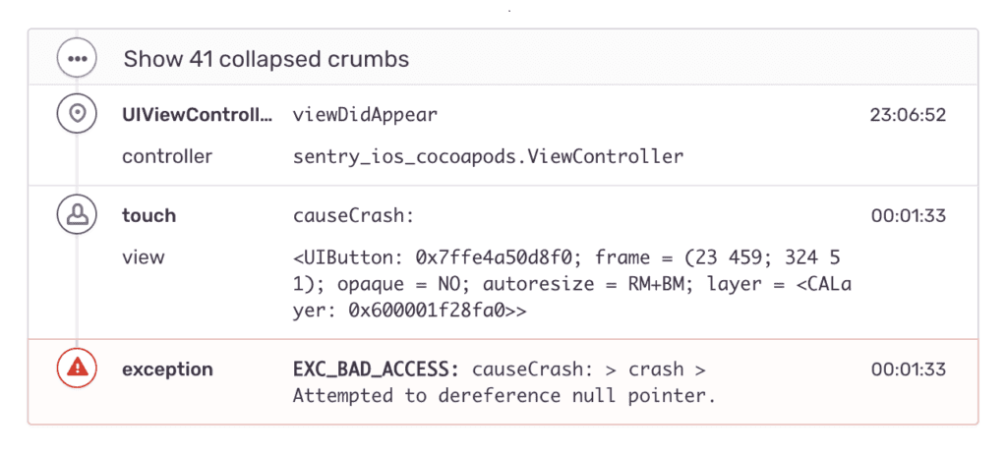Image source: https://sentry.io/welcome/

That means you can prioritize bugs by their impact on a business or users. Additionally, you can see the route cause of the error, so you don’t need to waste time debugging. Breadcrumbs are available both for Server Side and Client-side.

Sentry shows you everything you need to know to find and fix errors – the entire context. It can associate errors with the specific release. The **context** feature also provides full context on the environment of the error:

* Language;
* OS;
* Release;
* Environment.

Of course, you can set up a custom context.

And, finally, **releases**. With their help you can see who and when caused the error. Releases provide additional context, including rich commit data, so you know which errors were addressed and which were introduced for the first time.

#### ****Additional features****

* Custom queries;
* Source maps for JS and Node;
* Dashboard to analyze data;
* Stack trace;
* Cross-project issues.

#### ****Supported technologies****

Sentry supports several technologies for web, mobiles and even games:

* All technologies around Javascript, including frameworks and particular libraries;
* Mobile – Android and iOS;
* Desktop apps – MacOS, Windows and Linux.
* Unreal and C for games;
* Web backend technologies – Python, Ruby, PHP, etc.

#### ****Pricing options****

There are four pricing tiers:

* Developer – it is free, limited events volume;
* Team – $26/month;
* Business – $80/month, extended features;
* Enterprise – custom pricing, all features, and a dedicated manager.

There are also prepaid plans where you can extend the event’s volume.

#### ****Onboarding, installation process and dashboard****

There are several options to register in Sentry: social login or directly with email. After you register, the system offers you to choose the platform you want to track. For example, if you choose javascript, Sentry will show you a code snippet to pass into your application. Thus the installation process requires literally several minutes.

After that you will see quite an advanced admin with the statistics dashboard, projects and other features.

#### ****Documentation****

The docs are very advanced, well designed and work fast. They’re well grouped into blocks: Getting started, Platforms, API reference, Product, Data Management, Support and others. The docs are very easy to use.

#### ****Integrations****

Sentry has a huge number of options for integrating with other services. You can create a whole infrastructure for catching and correcting errors. Integrations are divided into blocks:

* Source code management (Github, Gitlab, and others). You can augment the errors with particular commits.;
* Deployment tools;
* Project Management tools (Jira and Asana). Assign bug fixes to the developers with the context from Sentry.;
* Notifications and messengers (Slack, Twilio). You can receive notifications about the errors right inside these tools. ;
* Data visualization (Datadog) – see and analyze errors over time.;
* Session replay tools (Fullstory and others). Get more context with video sessions.
* Authentication tools.

#### ****Conclusion****

Sentry is a very advanced and complete tool with a lot of platform support, good documentation, and a lot of integrations. In our opinion, there are two main disadvantages with Sentry – design may scare enterprise clients; user sessions replay is completely absent.

Instructions to get started with sentry:

<https://docs.sentry.io/product/sentry-basics/guides/integrate-backend/getting-started/> - this is a complete step by step on how to get started using Sentry. It is straight forward and I love that it is integrated with Github so I can easily use my repo for anything I wanna check.

Additional Resources on Setup:

[**https://docs.sentry.io/product/performance/getting-started/**](https://docs.sentry.io/product/performance/getting-started/)- this provides tools on how to set up with different ennvironments and languages.

https://develop.sentry.dev/self-hosted/

https://www.sitepoint.com/getting-started-with-sentry-io-error-tracking/